Nama : Tegar Kang Ageng Gilang

Nim : 2311104018

Kelas : SE-07-01

TP Modul 8

1.Implementasi Runtime Configuration

Bank_transfer_config.json

{

"lang": "id",

"transfer": {

"threshold": 25000000,

"low_fee": 6500,

"high_fee": 15000

},

"methods": ["RTO (real-time)", "SKN", "RTGS", "BI FAST"],

"confirmation": {

"en": "yes",

"id": "ya"

}

}

Bank_transfer.js

const fs = require('fs');

class BankTransferConfig {

constructor() {

const defaultConfig = {

lang: "en",

transfer: {

threshold: 25000000,

low_fee: 6500,

high_fee: 15000

},

methods: ["RTO (real-time)", "SKN", "RTGS", "BI FAST"],

confirmation: {

en: "yes",

id: "ya"

}

};try {

const data = fs.readFileSync('./bank_transfer_config.json', 'utf-8');

this.config = JSON.parse(data);

} catch (error) {

this.config = defaultConfig;

}

}

getConfig() {

return this.config;

}

}

module.exports = BankTransferConfig;

main.js

const readline = require('readline');

const BankTransferConfig = require('./bank_transfer');

const rl = readline.createInterface({

input: process.stdin,

output: process.stdout

});

const configLoader = new BankTransferConfig();

const config = configLoader.getConfig();

const lang = config.lang;

const threshold = config.transfer.threshold;

const lowFee = config.transfer.low_fee;

const highFee = config.transfer.high_fee;

const methods = config.methods;

const confirmation = config.confirmation;

const askAmount = lang === "en"

? "Please insert the amount of money to transfer: "

: "Masukkan jumlah uang yang akan di-transfer: ";

rl.question(askAmount, (amountInput) => {

const amount = parseInt(amountInput);

const fee = amount <= threshold ? lowFee : highFee;const total = amount + fee;

if (lang === "en") {

console.log(`Transfer fee = ${fee}`);

console.log(`Total amount = ${total}`);

console.log(`\nSelect transfer method:`);

} else {

console.log(`Biaya transfer = ${fee}`);

console.log(`Total biaya = ${total}`);

console.log(`\nPilih metode transfer:`);

}

methods.forEach((method, i) => {

console.log(`${i + 1}. ${method}`);

});

rl.question('\n> ', () => {

const confirmPrompt = lang === "en"

? `Please type "${confirmation.en}" to confirm the transaction: `

: `Ketik "${confirmation.id}" untuk mengkonfirmasi transaksi: `;

rl.question(confirmPrompt, (confirmInput) => {

const validConfirm = lang === "en" ? confirmation.en : confirmation.id;

if (confirmInput.trim().toLowerCase() === validConfirm.toLowerCase()) {

console.log(lang === "en" ? "The transfer is completed" : "Proses transfer

berhasil");

} else {

console.log(lang === "en" ? "Transfer is cancelled" : "Transfer dibatalkan");

}

});

});

});

rl.close();

Output :

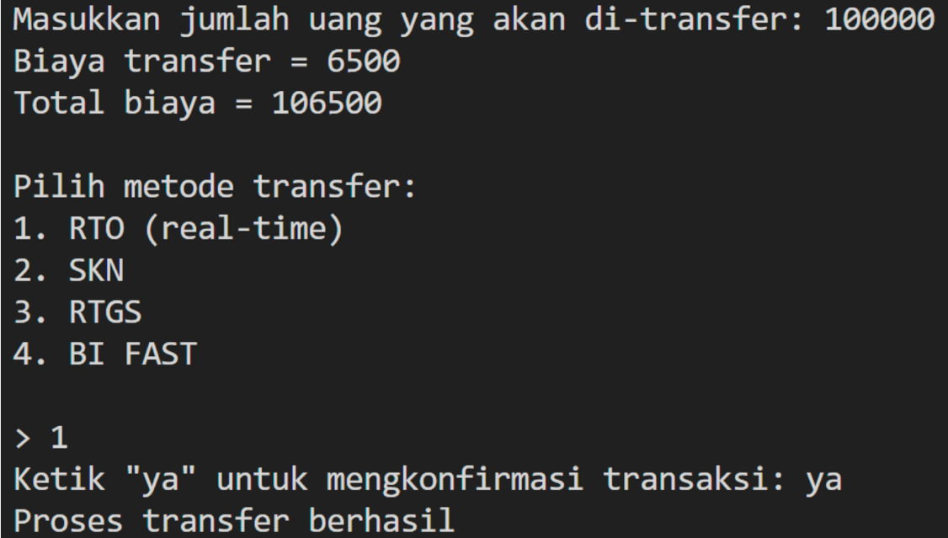

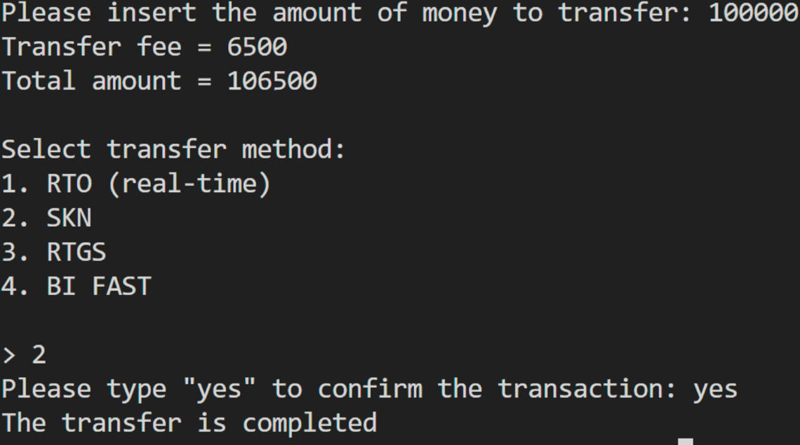

Penjelasan :

Kode diatas mengimplementasi runtime configuration menggunakan file

bank_transfer_config.json untuk mengatur bahasa, batas biaya transfer, metode

transfer, dan konfirmasi transaksi. File tersebut diproses melalui class

BankTransferConfig, yang membaca konfigurasi atau menggunakan nilai default jika

file tidak ditemukan. Program utama akan meminta input jumlah uang yang akan

ditransfer, menghitung biaya berdasarkan ambang batas (threshold), lalu

menampilkan total biaya serta daftar metode transfer. Setelah pengguna memilih

metode, program meminta konfirmasi dalam bahasa yang sesuai (id atau en) sebelum

menyelesaikan atau membatalkan transaksi.